**SLIDE 1**



Welcome to the new semester, one that will be “exceptional in nature.” I am preparing these lectures for both “in-person” delivery and for those who are taking the course online.

When lecturing I will be paraphrasing this transcript, reading it word for word would be boring and I am not going to memorize it. However, during the in-person lecture I will be presenting from these MS PowerPoint slides and all in-class code examples and demonstrations will be identical to those contained on the MS PowerPoint slides. So, whether you are in class or “online” you can rest assured that you will be working with the same material.

On this first slide is information on how to get in touch with me and office hours. All office hours meetings will be via “Zoom.” For those students taking the course online please be aware that all posted times are “Eastern Time U.S.” If for some reason you cannot meet during the posted hours, contact me and I will try to accommodate you.

**SLIDE 2**

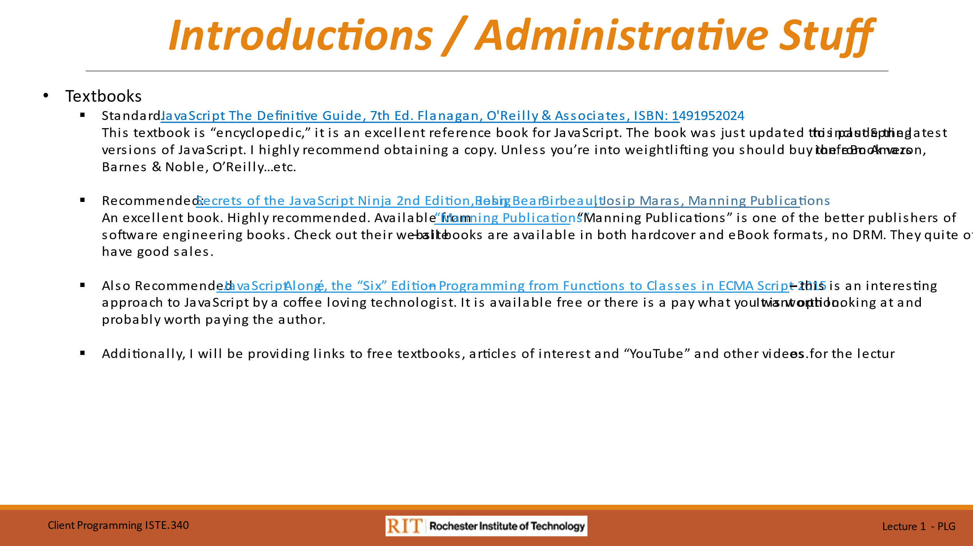

This slide is self-explanatory.

I cannot make you buy any of these books, but I do recommend you at least purchase the eBook version of JavaScript The Definitive Guide. It will serve as an excellent reference.

The second book, Secrets of the JavaScript Ninja is an excellent source for JavaScript and is highly recommended. The lead author John Resig is a RIT graduate. We will mention him again when we study jQuery – he invented it.

**SLIDE3**



This slide is self-explanatory.

Take a few minutes and explore the first three websites.

**SLIDE 4**

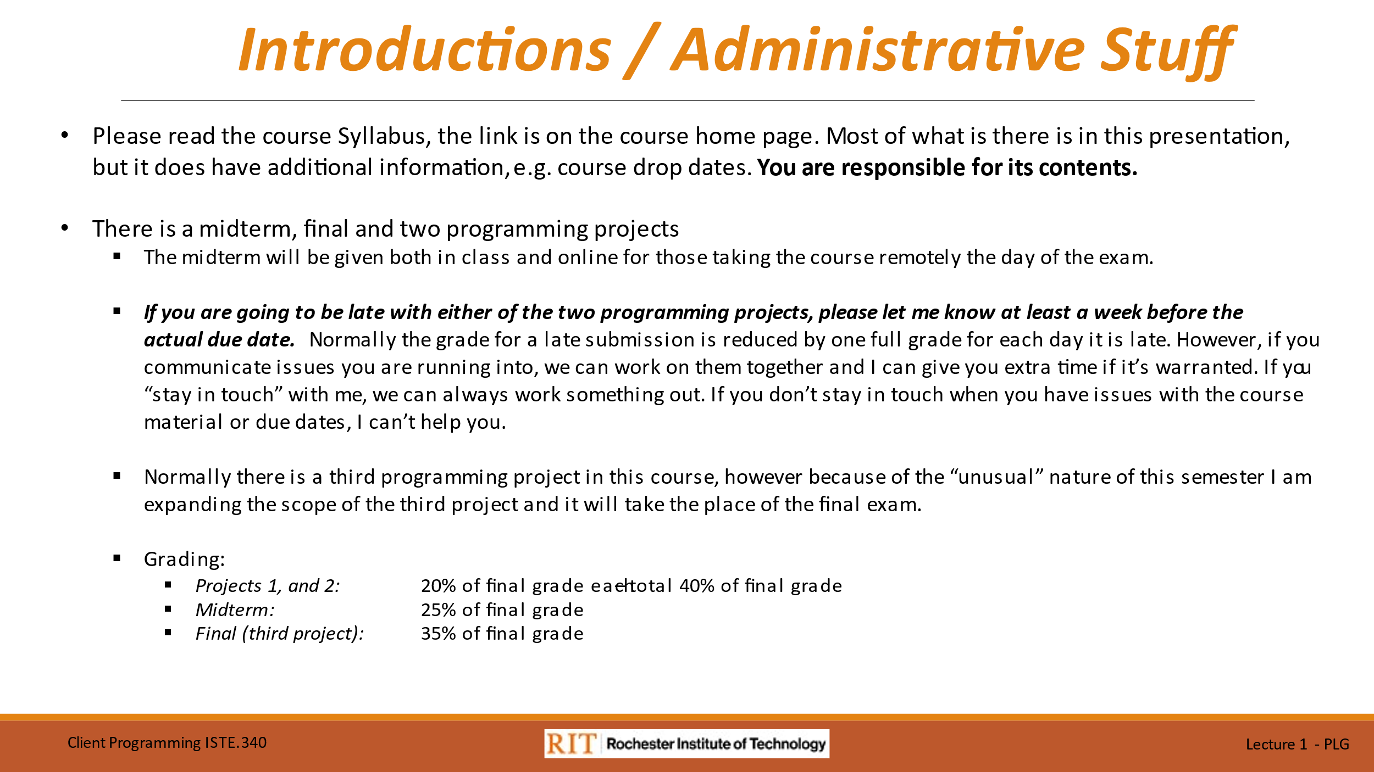

Like it says, read the course syllabus.

This is what will go into your final grade.

What I really want to emphasize is that if you are having difficulty with any material which will affect you meeting a project due date, PLEASE REACH OUT. If you communicate with me, we can figure out how you can get the project done without penalties. You must let me know a minimum of one week before a project due date that you are having a problem meeting the due date to avoid automatic grade penalties for lateness.

**SLIDES 5 & 6**





This is the third year I am teaching this course, enough time for me to figure things out. I started teaching the course with a syllabus that had been “in place” for a while. Looking at the syllabus and comparing it to what I have been doing professionally, I have been in the IT field for 45, years, I felt that some updates to the syllabus were in order. Over the last year and a half, with department permission, I have started to make some of these updates.

As part of studying “Client-side” JavaScript we make use of the jQuery library to simplify modifications of the “Document Object Model,” “DOM,” that is the object we write our JavaScript programs against to interact with the web browser. As you will see, modifying the “DOM” with “plain” JavaScript is somewhat complex, jQuery simplifies things. However, while you will find jQuery in almost any website you look at, and when you start working in industry it is likely that one of the first things you will be asked to do is to modify an existing website where you’ll come across jQuery, it is not in the forefront of current development work.

This semester I thought I would try to introduce a more contemporary JavaScript library: React.js. After we look at jQuery it will make a nice contrast. However, this is a totally new topic and a bit “experimental” so we will not spend a great deal of time on it and *it will not be part of any examinations nor will you be required to use it in any our projects*. As mentioned in the slide: “if you want to try to use it, I encourage you to do so.

Traditionally the last part of the course was devoted to creating client-side programs using Microsoft Windows Forms. I felt that this was a little too “old school” and not terribly strategic. I thought that it would be more worthwhile to introduce Microsoft’s strategic open-source .NET Core platforms which continue to gain traction in the marketplace. I did this for the first-time last semester, and it proved to be a great success.

For the last part of the course, we will be building client-side applications with the Microsoft .NET Core / ASP.NET Core frameworks. In fact, we will learn how to build an application using either MS Visual Studio for Windows or macOS and then without any modifications to the program deploy it to MS Windows, macOS and Linux.

**SLIDE 7**



The truth of the first quote from Reginald Braithwaite, author of the recommended text JavaScript Alongé, will become apparent as we learn JavaScript. JavaScript will truly try to do anything you asked it to. For instance, it is an untyped language meaning that if you try to perform an operation with mixed data types that would cause an exception in Java or C#, JavaScript will do its best to accommodate you. There will be instances where you run a JavaScript program and it completes but it appears as if nothing happened. JavaScript tried to do what you asked but it could not, and it did not give you any indication that anything was wrong. Learning to debug JavaScript will be part of our work.

The second quote, from the other recommended text Secrets of the JavaScript Ninja, is especially important. The only thing that Java and JavaScript have in common is that they both start with “Java.” We will get a little bit into “functional programming” during the semester but this quote by Michael Feathers[1] sums things up nicely:

*OO (Object Oriented) makes code understandable by encapsulating moving parts.*

*FP (Functional Programming) makes code understandable by minimizing moving parts.*

As to fundamental differences between JavaScript concepts and other languages, we will peek at JavaScript Objects, one of the things that are different, in this lecture and expand on them later – they are different.

**SLIDES 8, 9 & 10**

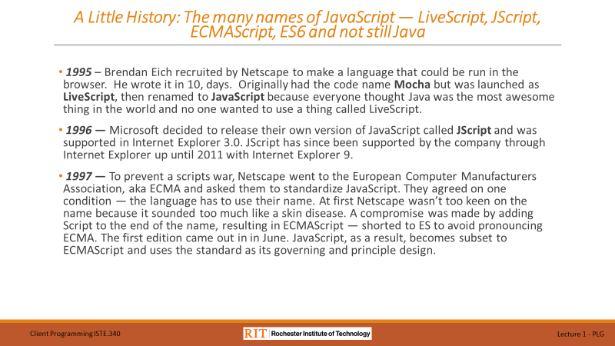





I am not going to spend a lot of time on these three slides. However, as you’ll see through the course, I do like to take a moment to add a little historical perspective to the topics we study.

Take a moment to read through them and explore the links at your leisure.

**SLIDE 11**



The software that you should have installed on your own development machine is listed on this slide. All the software is available free of charge for both MS Windows, macOS and Linux

While we will initially use the “console” in the Google Chrome browser “Developers Tools” to try out JavaScript code in the “REPL” environment, when we start running our HTML / JavaScript pages in Chrome you will learn how to use the rich set of features available in the “Developers Tools” for sophisticated debugging.

Similarly, we will initially use MS Visual Studio code for writing and debugging “Core JavaScript” programs with the “Node.js” runtime available in Visual Studio code. However, when we start building our HTML/JavaScript pages we will do all our programming in Visual Studio Code.

**SLIDES 12 – 18**



I am only showing Slide 12, here.

Slides 12, through 18, are designed to be self-contained step by step instructions for trying out JavaScript in the Chrome browser “Developer Tools” console.

If you are viewing this lecture remotely and have any questions, please drop me an email or schedule office hours.

**SLIDE 19**

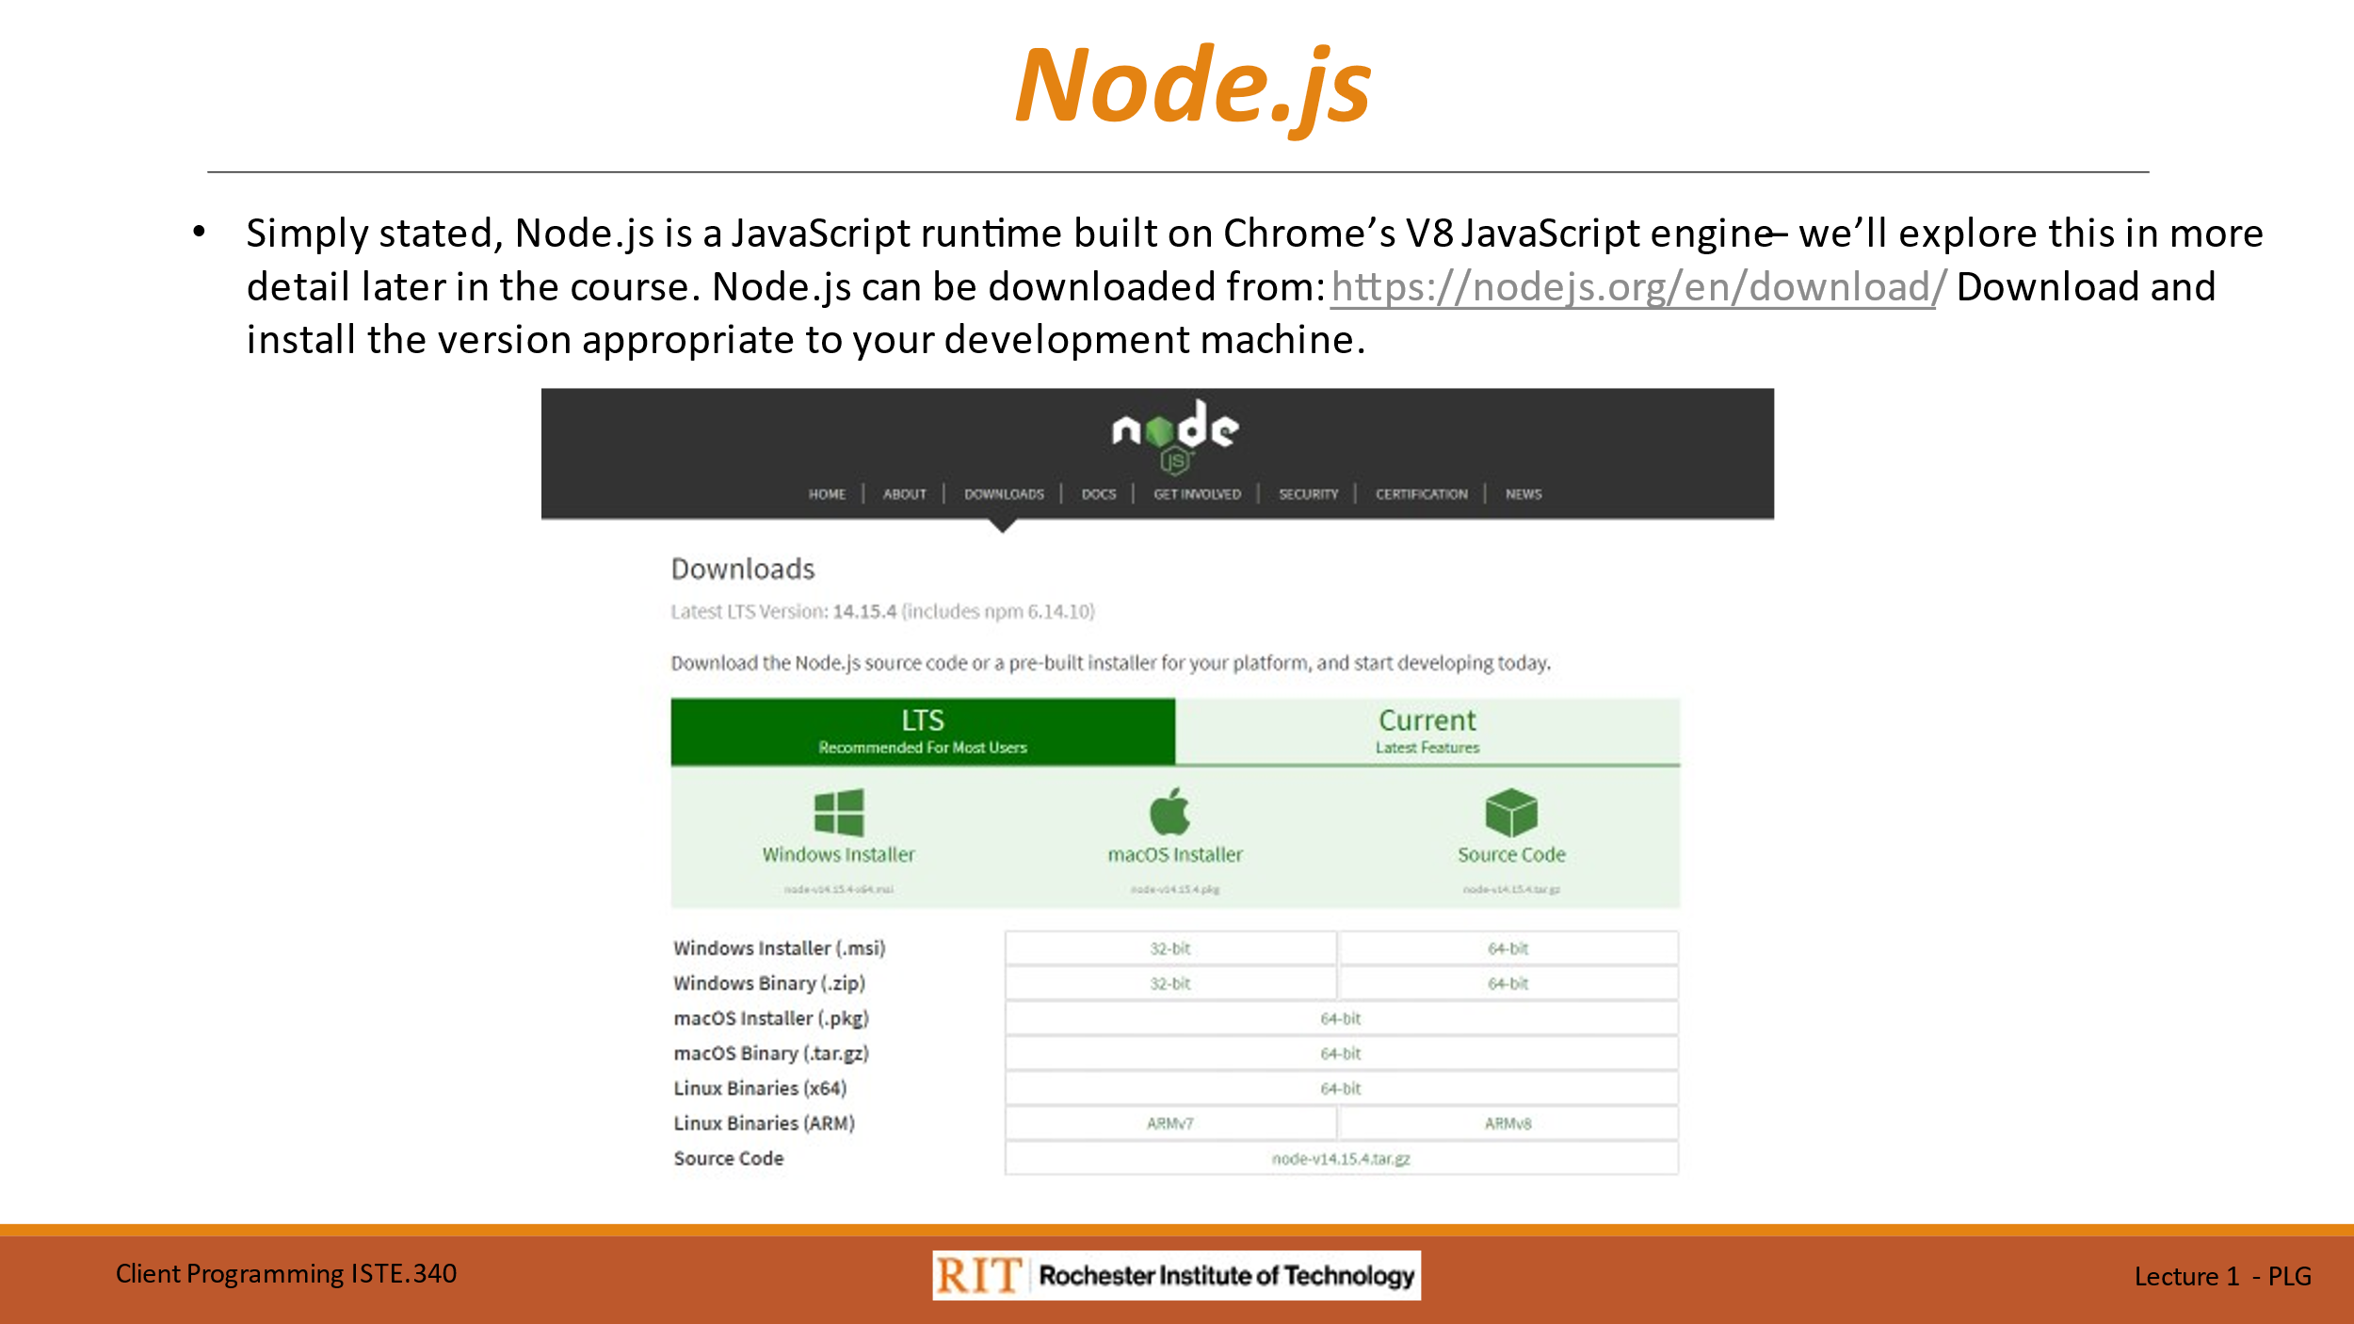

On this slide you have the download link for the latest version of Node.js for:

* MS Windows
* macOS
* Linux

Download and install the version that is appropriate to your development machine.

**SLIDE 20**



This slide shows you how to open a JavaScript “REPL” from the Node.js command prompt.

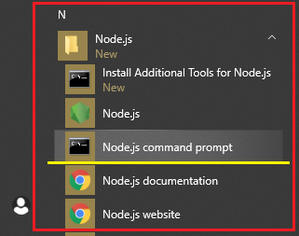

If you are running MS Windows 10, open the start menu and scroll down to the “Node.js” entry and expand it. From the expanded menu click on “Node.js command prompt.” That will bring you to the “Node.js command prompt window.

Once you have the “REPL” command prompt ‘>’ showing, run the examples we did in the Chrome “Developers Tools” console as an exercise.

**SLIDE 21**



This slide is just a recap of what MS Visual Studio Code is and the “main” thing we will use it for.

**SLIDE 22**



As with Node.js, this slide shows the download site for MS Visual Studio Code. Please download and install the version appropriate to your development machine.

**SLIDES 24, through 30**



I am only showing Slide 24, here.

Slides 24, through 30, are designed to be self-contained step by step instructions for trying out JavaScript using Visual Studio Code and the Node.js runtime environment.

1. <https://www.r7krecon.com/michael-feathers-bio>